* **Project name:** Homeautomation*.*
* **Team Members**

1. *Mariam Tarek*
2. *Nourhan Shaban*
3. *Nada Mamdouh*
4. *Nada Hassan*
5. *Nada Abdul Hamid*
6. *Noura Gaber*

**Business Case:** The project discussed in this paper aims to solve the various problems that people face in their daily lives. It is designed to control and monitor devices via smartphone using Wi-Fi as a communication protocol and raspberry pi as a private server. All devices and sensors are connected to the internet via a micro-controller that acts as a gateway to the internet. Even if the user goes inside, the app is designed to automatically switch to a state that automatically controls the devices according to sensor readings. Also, the data is logged into the server for future data extraction.

* **Deliverable "Goal":** *provides control of lighting, air conditioning, screens, and security system remotely, without the need to do these things manually.*

**Objectives:**

Android-controlled Smart Home Automation should be able to control the home appliances wireless effectively and efficiently.

**1-Controlling Home Appliances via Application (Switch and Voice Mode)**

**2-Secure Connection Channels between Application and Raspberry pi**

**3-Controlled by any device capable of Wi-Fi (Android, iOS, PC)**

**A 4-Extensible platform for future enhancement.**

**5- It provide the user with a report (daily, weakly, or monthly) of the Consumption of each device to help him to reduce the total consumption**

**6**-**It sends a notification to the user if there is a device still turned on for a long time, and the user can allow access to turn it off automatically.**

**7**-**It shows the user with the most electricity-consuming devices and suggests turning it off.**

*Constraints:*

* + Budget: around $500,000.
  + Time: 22 weeks

**Resources:**

1. A-Team of electrical engineers.
2. A-Team of programmers.
3. Devices of the receiver.

**Deliverable:**

1. Devices: Devices through which the application is able to control lighting, heat and security must be imported.
2. Design: The program code through which the devices are controlled will be written.
3. Coding “developing”: Installing appliances on home appliances that you control.
4. Integration: The hardware and code are integrated to be controlled through the program.

**Scope Statement:**

* Before talking about the advantages and benefits of home automation applications, let's first discuss what home automation is the act of converting a traditional home into a "smart home. By adding advanced technologies -like sensors and communication modules - into everyday household appliances. These devices connect to a network that homeowners can access to see data about their homes. In simple terms, home automation is the ability to control your home without effort.
* **Work steps***:*
* This Application will be responsible for communication from gateway through Wi-Fi:

1. It will ask for login and password so that unauthorized users won’t be able to use it.
2. It will send a command for specific data as required by the user.
3. It will display the data sent by the gateway in a different form.
4. There are various Buttons for various types of data to be displayed.
5. On each click a specific command will be sent so that gateway will recognize that which data to be sent to the user from Database.

* **Milestone:**

1. The First Ten weeks to import The Devices that will be Used.
2. For Six weeks to write The Software Code that Controls The Hardware.
3. For Two weeks to install Control Devices In Home appliances.
4. For Four weeks to integrate Devices and Code to Control them through The Program.

**Risk management:**

1. High costs of devices.
2. Lack of home automation standards.
3. Appliance or property damage.
4. A delay in receiving the equipment.
5. A shortage in the project budget.
6. Devices not matching with the application.
7. Slow communication between devices and applications.
8. Delays in the application update work*.*

* **Risk solving:**

1. To avoid delays in receiving the devices, the two parties agree on a specific date for receiving the devices.
2. Increasing customs prices and tools used in the implementation of the project.
3. Checking the necessary standards and quality of the equipment used.
4. The use of high-quality materials while using the device.
5. Development from the experience of programmers.

* **Communication Management Plan:**

*Weekly => Thursday at 09:00 PM*

**Responsibility Matrix:**

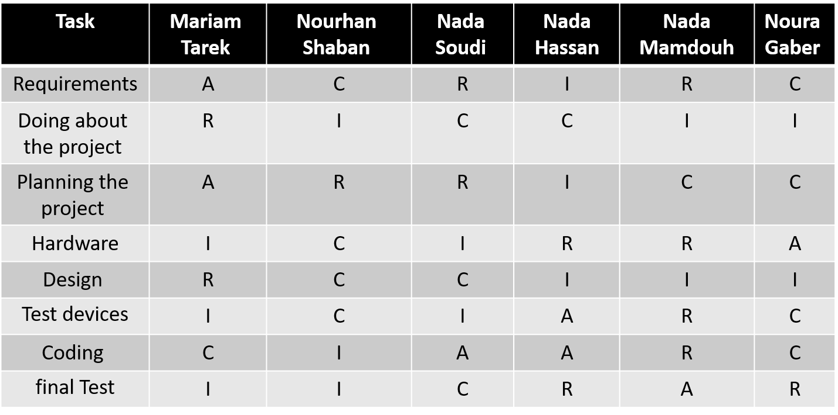

* **WBS:**

Get away

Planning

Hardware

Coding

Testing

4.1 Test the Application

3.1 Coding the Functions in all Tasks

3.2 Test Devices

2.1

Hardware installation

2.2

Design

1.1

Requirements

1.2

Doing Study

about the

Project

1.3

Plan the Project

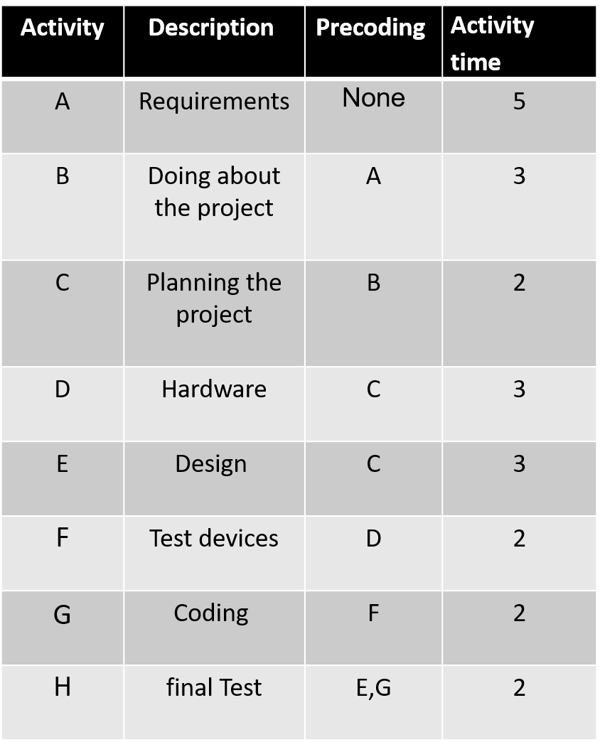

* **Project Network:**

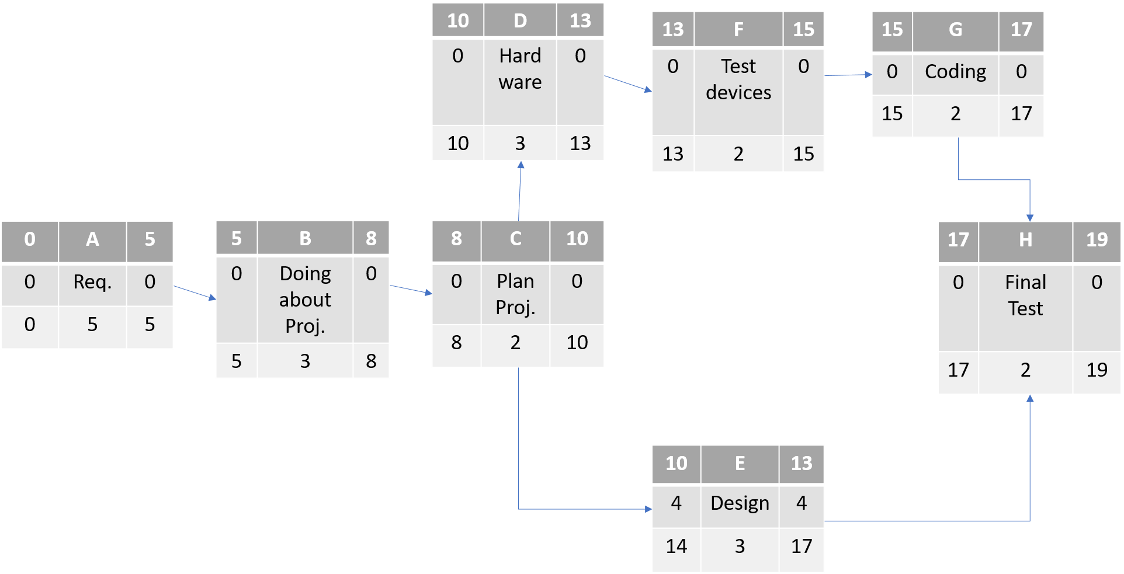

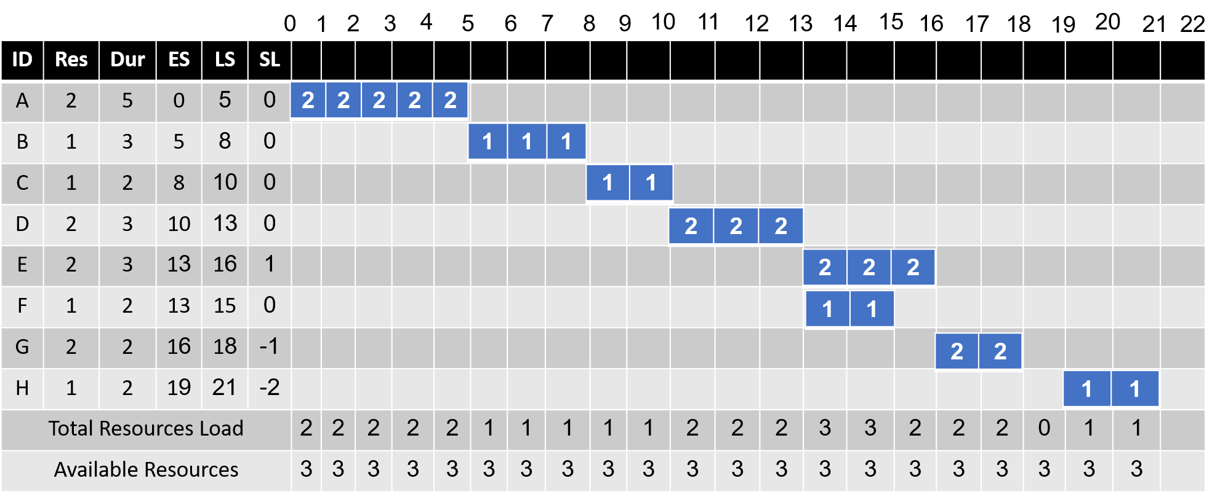

**Time-Phased Budget**:

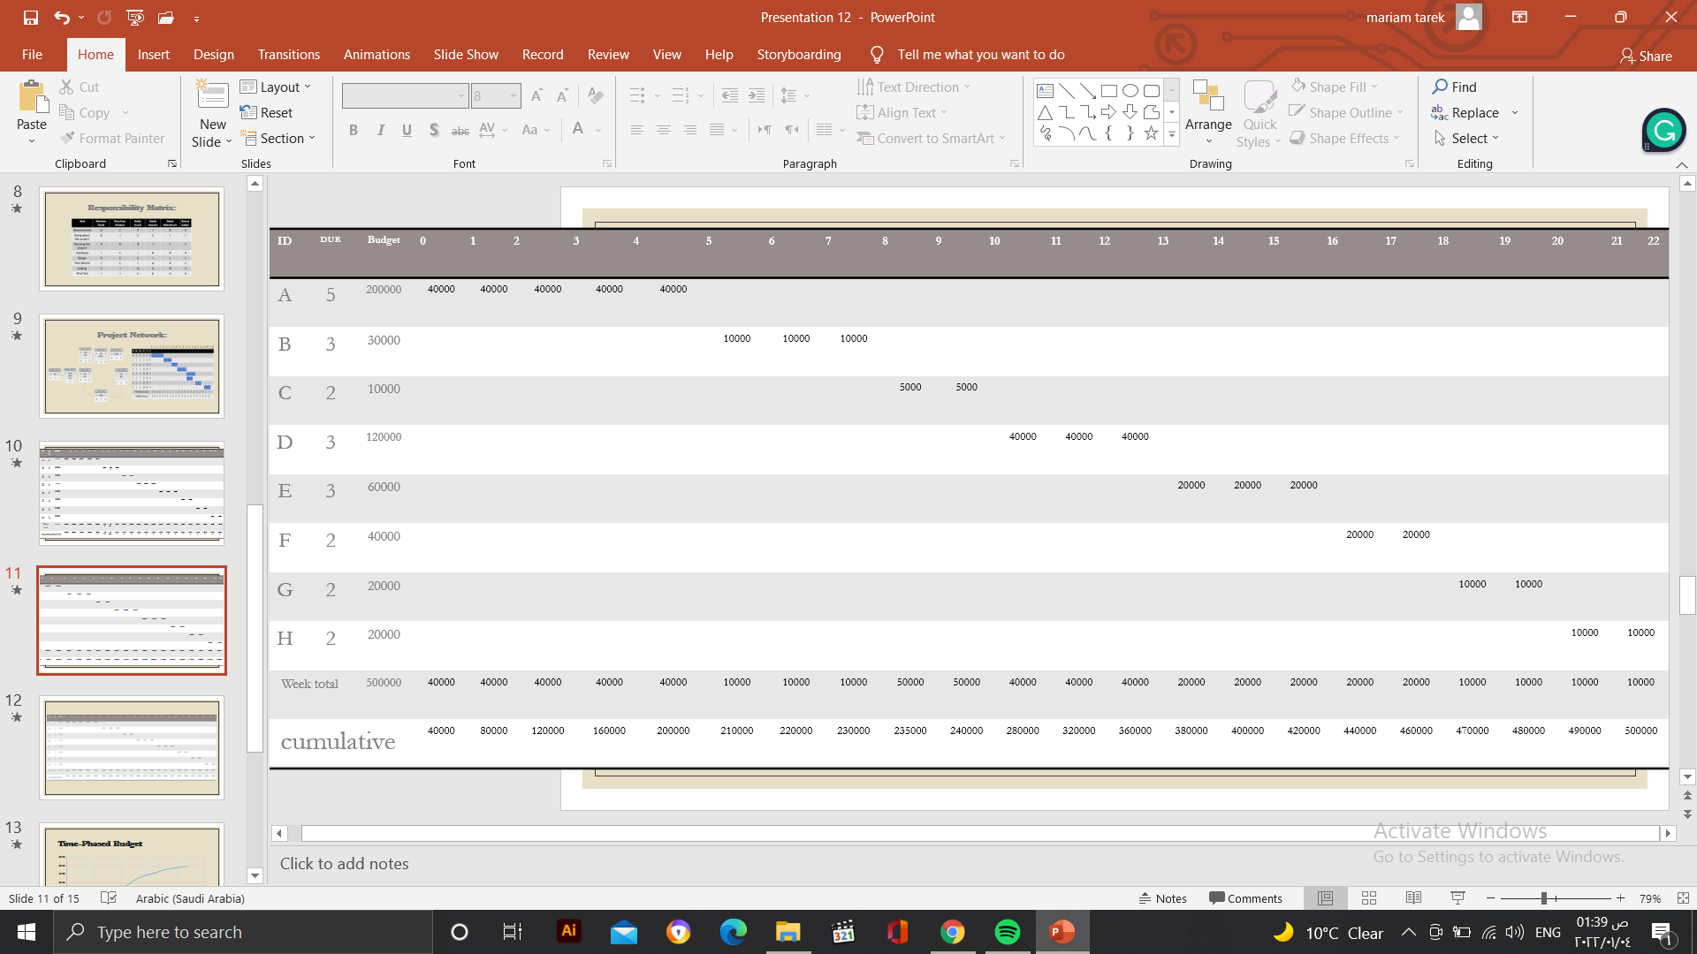

**Cumulative Baseline Budget (PV)**:

Gant chart:

